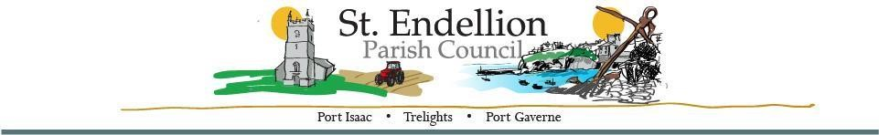
NOTICE AND AGENDA OF THE FULL COUNCIL MEETING
TO BE HELD AT ST ENDELLION HALL
ON MONDAY 9th OCTOBER 2023 AT 7pm
Members of the public who wish to make representations on any of the items listed below are asked to contact
the Clerk by emailing stendellionpc@gmail.com by noon on Monday 9th October 2023

Minute | Agenda Items | Action
 | Present
23/163 | Members’ Declarations  - Pecuniary/Registerable Declarations of Interests – Members must declare an interest, which has been declared on their Register of Financial Interests form, relevant to the agenda.  - Non-registerable Interests – Members must declare non-pecuniary interests at the start of the meeting or whenever the interest becomes apparent.  - Declaration of Gifts – Members are reminded they must declare any gift or hospitality with a value in excess of fifty pounds.  Dispensations – Members to consider any written requests for dispensations.
23/164 | Apologies  C&M S Ms Jon,
23/165 | Chair’s Welcome / Public Forum  Members of the Public may address the Council for a maximum of three minutes, prior to the commencement of the meeting. All comments are to be directed to the Chair of the meeting.
23/166 | Minutes of Meetings  a. Full Council Meeting – 11th September 2023
23/167 | Organisations and Reports  - Parish Council Chair – Members to receive a report.  - Divisional Members Report- Members to receive a report.  - Playing Field Development Working Party- Members to receive an update.  - STEND_HWG – Members to receive an update.  - Bodmin, Wadebridge, Padstow, St Teath & Tintagel Community Area Partnership – Members to receive a report | Cllr. Raynor  Cllr. Mould  Cllr. Button  Cllr. Williams  Cllr. Raynor
23/168 | Planning Applications – Members to consider the following, including any received after the agenda had been published.  - PA23/07080 9 & 10 The Terrace Port Isaac  Proposed ground and first floor extensions with internal alterations.  - PA23/06951 26 New Road Port Isaac  Replacement external windows and doors to shop frontage.  - PA23/06660 Tolraggott Farm Trelights  Roofed structure with concrete walls to hold cut grass/maize for silage.  - PA23/07554 Treswarrow Trelights  Installation of Solar Array.
23/169 | Cornwall Council Planning Decisions – information only.  - PA23/07346 Street Record Lundy Road Port Isaac  Proposals to install fibre-optic network cabinets.  Closed - advice given.  - PA23/05694 White House Cottage 3A Roscarrock Hill  Non Material Amendment (1) to Application No. PA21/06026 dated 24th November 2021 for Two storey extension to the rear of the property with glazed link between the existing summer room and dwelling (Revision to previously approved planning application PA19/09978), namely, to place vertical slate hanging to match existing to upper section of the summer house to mask steel beam.  Approved unconditional
23/170 | Licensing Applications – Members to consider the following, including any received after the agenda had been published.  None
23/171 | Environmental / Amenity Matters – including the Contract & Maintenance Supervisor Report and any items received after the agenda was issued:  - Deli Box - The tenants at the Deli-Box, New Road would like to pay the rent ahead i.e. from the next payment through to February 2024.  - Main Car Park – As there have been a number or issues with the ticket machines in Main car park this summer; would Members consider having an amount set aside for future replacement machines?
23/172 | Highway Matters  - Signage - Daisy Hicks Corner  - Cllr Williams / Cllr Symons Proposal: After many years of unsuccessful attempts to encourage landowners to take responsibility for the banks on land in their ownership, and the inability of the LA to contact landowners to remind them of their statutory duty with any visible effect, we suggest the PC assumes responsibility on an annual basis to ensure banks in the CA are kept in a good state.  Therefore we propose the PC conducts an audit and assumes responsibility for the banks on Trewetha Lane & Back Hill and uncut areas of Church Hill, Port Isaac. Please suggest any amendments to further the aim of the proposal.
23/173 | Financial Matters –  - Accounts for Payment – members to review accounts previously emailed for approval.  - Payroll - members approval for next month.
23/174 | Administrative Matters
23/175 | Documentation / Correspondence – not covered elsewhere on the agenda, including any items received after the agenda had been issued.
23/176 | Diary Dates – including any dates received after the agenda had been published. Details previously emailed.  - Full Council Meeting – Monday 13th November 2023 7pm
23/177 | Information Only / Future Agenda Items
23/178 | Closed Session – in view of the special/confidential nature of the business about to be transacted, it is advisable in the public interest that the press and public be excluded, and they are instructed to withdraw.
23/179 | Meeting Closed –

Signature: D Harrison (Clerk) Date: 9/10/2023

