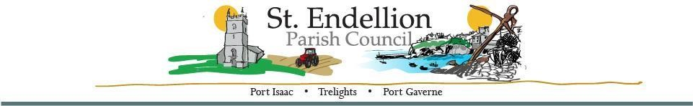
NOTICE AND AGENDA OF THE FULL COUNCIL MEETING
TO BE HELD AT ST ENDELLION HALL
ON MONDAY 13th November 2023 AT 7pm
Members of the public who wish to make representations on any of the items listed below are asked to contact
the Clerk by emailing stendellionpc@gmail.com by noon on Monday 13th November 2023

Minute | Agenda Items | Action
 | Present
23/112 | Members’ Declarations  - Pecuniary/Registerable Declarations of Interests – Members must declare an interest, which has been declared on their Register of Financial Interests form, relevant to the agenda.  - Non-registerable Interests – Members must declare non-pecuniary interests at the start of the meeting or whenever the interest becomes apparent.  - Declaration of Gifts – Members are reminded they must declare any gift or hospitality with a value in excess of fifty pounds.  Dispensations – Members to consider any written requests for dispensations.
23/113 | Apologies
23/114 | Chair’s Welcome / Public Forum  Members of the Public may address the Council for a maximum of three minutes, prior to the commencement of the meeting. All comments are to be directed to the Chair of the meeting.
23/115 | Minutes of Meetings  a. Full Council Meeting – 9th October 2023
23/116 | Organisations and Reports  - Parish Council Chair – Members to receive a report.  - Divisional Members Report- Members to receive a report.  - Playing Field Development Working Party- Members to receive an update.  - STEND_HWG – Members to receive an update.  - Bodmin, Wadebridge, Padstow, St Teath & Tintagel Community Area Partnership – Members to receive a report | Cllr. Raynor  Cllr. Mould  Cllr. Button  Cllr. Williams  Cllr. Raynor
23/117 | Planning Applications – Members to consider the following, including any received after the agenda had been published.  - PA23/07674 19 Rose Hill Port Isaac  Replacement of West extension, new second floor rear extension, new front door canopy/porch, internal and external alterations.  - PA23/08205 6 & 8 Trelights Port Isaac  Deed of Modification to s.106 dated 30.06.2010 to update the Mortgage Exemption clauses for 6 & 8 Trelights in Port Isaac.  - PA23/00995/PREAPP Glebe Farm St Endellion Road St Endellion  Planning Performance Agreement for the construction of 25 affordable dwellings and between 3 live/work units, and 3 commercial units, including appearance, layout and scale, along with heritage and landscape impacts, highways, access and drainage.  - PA23/082455 Land North West of Trevathan Farm St Endellion Port Isaac  Erection of a cattle shed.  - PA23/06515 Amended Plans 2 Cliffside Port Isaac  Proposed single storey extension with balcony terrace over creating an additional and minor internal re-ordering of an existing dwelling to include the adaptation of 2no. dormer roofs and the addition of 1no. dormer roof.
23/118 | Cornwall Council Planning Decisions – information only.  - PA23/08292 8 Under Town Trelights Port Isaac  Deed of Modification to s.106 agreements dated 30.06.10 and 31.03.17 for 6 and 8 Under Town in Port Isaac.  Decided - Modification of S52/S106 agreed.
23/119 | Licensing Applications – Members to consider the following, including any received after the agenda had been published.  None
23/120 | Environmental / Amenity Matters – including the Contract & Maintenance Supervisor Report and any items received after the agenda was issued:  - Main Car Park – Revisit now C&M S is Present. As there have been a number or issues with the ticket machines in Main car park this summer; would Members consider having an amount set aside for future replacement machines?
23/121 | Highway Matters
23/122 | Financial Matters –  - Accounts for Payment – members to review accounts previously emailed for approval.  - Payroll - members approval for next month.
23/123 | Administrative Matters  - Co-Option Interested Parties – Two candidates have shown interest via email.
23/124 | Documentation / Correspondence – not covered elsewhere on the agenda, including any items received after the agenda had been issued.
23/125 | Diary Dates – including any dates received after the agenda had been published. Details previously emailed.  - Full Council Meeting – Monday 11th December 2023 7pm
23/126 | Information Only / Future Agenda Items
23/127 | Closed Session – in view of the special/confidential nature of the business about to be transacted, it is advisable in the public interest that the press and public be excluded, and they are instructed to withdraw.
23/128 | Meeting Closed –

Signature: ……………………………………………… D Harrison (Clerk) Date: 6/11/2023

