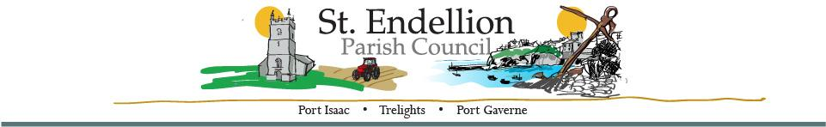

NOTICE OF THE ANNUAL PARISH MEETING OF ELECTORS 2024

To be held at St. Endellion Hall on 8th April 2024 at 7pm, immediately prior to the monthly parish council meeting.

This meeting will be open to the public. The agenda will be available on the parish council website from 25th March 2024.

Dated this 24th March 2024
D. Harrison – Chair, St. Endellion Parish Council

